DS Lab Programs
Name: K.Thanunjay Ram
Class: CSE(AI)-B
Roll no.: 160724754079
Week 1:03/02/2026
- Create an account in github and link the repository with the google colab
- Write the code to implement the following data structures
  - List
a=[10,20,30]
print(type(a))
lst = [10, 20, 30, 40]
print("Initial list:", lst)
print("First element:", lst[0])
print("Last element:", lst[-1])
lst.append(50)
print("After append:", lst)
lst.insert(2, 25)
print("After insert:", lst)
lst.extend([60, 70])
print("After extend:", lst)
lst.remove(25)
print("After remove:", lst)
lst.pop()
print("After pop:", lst)
lst.pop(1)
print("After pop at index 1:", lst)
lst[0] = 100
print("After updating:", lst)
print("Index of 30:", lst.index(30))
print("Count of 20:", lst.count(20))

Output:

<class 'list'>
Initial list: [10, 20, 30, 40]
First element: 10
Last element: 40
After append: [10, 20, 30, 40, 50]
After insert: [10, 20, 25, 30, 40, 50]
After extend: [10, 20, 25, 30, 40, 50, 60, 70]
After remove: [10, 20, 30, 40, 50, 60, 70]
After pop: [10, 20, 30, 40, 50, 60]
After pop at index 1: [10, 30, 40, 50, 60]
After updating: [100, 30, 40, 50, 60]
Index of 30: 1
Count of 20: 0

  - Tuples
# TUPLE OPERATIONS
t = (10, 20, 30, 40)
print("Original tuple:", t)
print("First element:", t[0])
print("Last element:", t[-1])
print("Sliced tuple:", t[1:4])
print("Length of tuple:", len(t))
print("Count of 20:", t.count(20))
print("Index of 40:", t.index(40))
t2 = (50, 60)
t3 = t + t2
print("After concatenation:", t3)

Output:

Original tuple: (10, 20, 30, 40)
First element: 10
Last element: 40
Sliced tuple: (20, 30, 40)
Length of tuple: 4
Count of 20: 1
Index of 40: 3
After concatenation: (10, 20, 30, 40, 50, 60)

  - Sets and
# SET OPERATIONS
s1 = {10, 20, 30}
s2 = {30, 40, 50}
print("Union using method:", s1.union(s2))
print("Intersection using method:", s1.intersection(s2))
print("Difference using method:", s1.difference(s2))
print("Symmetric difference using method:", s1.symmetric_difference(s2))

Output:

Union using method: {50, 20, 40, 10, 30}
Intersection using method: {30}
Difference using method: {10, 20}
Symmetric difference using method: {40, 10, 50, 20}

  - Dictionaries
# DICTIONARY OPERATIONS
d = {
"name": "K.Thanunjay",
"age": 19,
"course": "BTech"
}
print("Original dictionary:", d)
print("Name:", d["name"])
print("Age:", d.get("age"))
d["college"] = "XYZ University"
print("After adding:", d)
d["age"] = 21
print("After updating:", d)
d.pop("course")
print("After pop:", d)
removed_item = d.popitem()
print("After popitem:", d)
print("Removed item:", removed_item)
print("Keys:", d.keys())
print("Values:", d.values())
print("Items:", d.items())
print("Is 'name' a key?", "name" in d)
print("Length of dictionary:", len(d))
# Nested dictionary
student = {
"id": 1,
"info": {
"name": "Amit",
"marks": 70
}
}
print("Nested dictionary value:", student["info"]["marks"])

# Clearing dictionary
d.clear()
print("After clear:", d)

Output:

Original dictionary: {'name': 'K.Thanunjay', 'age': 19, 'course': 'BTech'}

Name: K.Thanunjay

Age: 19

After adding: {'name': 'K.Thanunjay', 'age': 19, 'course': 'BTech', 'college': 'XYZ University'}

After updating: {'name': 'K.Thanunjay', 'age': 21, 'course': 'BTech', 'college': 'XYZ University'}

After pop: {'name': 'K.Thanunjay', 'age': 21, 'college': 'XYZ University'}

After popitem: {'name': 'K.Thanunjay', 'age': 21}

Removed item: ('college', 'XYZ University')

Keys: dict_keys(['name', 'age'])

Values: dict_values(['K.Thanunjay', 21])

Items: dict_items([('name', 'K.Thanunjay'), ('age', 21)])

Is 'name' a key? True

Length of dictionary: 2

Nested dictionary value: 70

After clear: {}

- Write the code to download, save and transform the data sets from the URL
import pandas as pd
url="https://raw.githubusercontent.com/dataprofessor/data/master/BostonHousing.csv"
df=pd.read_csv(url)
print(df.head())
df.to_csv(r"d:BostonHousing.csv",index=False)
print("Data Set save sucessfull to local drive")

Output:

crim zn indus chas nox rm age dis rad tax ptratio \
0 0.00632 18.0 2.31 0 0.538 6.575 65.2 4.0900 1 296 15.3
1 0.02731 0.0 7.07 0 0.469 6.421 78.9 4.9671 2 242 17.8
2 0.02729 0.0 7.07 0 0.469 7.185 61.1 4.9671 2 242 17.8
3 0.03237 0.0 2.18 0 0.458 6.998 45.8 6.0622 3 222 18.7
4 0.06905 0.0 2.18 0 0.458 7.147 54.2 6.0622 3 222 18.7

b lstat medv
0 396.90 4.98 24.0
1 396.90 9.14 21.6
2 392.83 4.03 34.7
3 394.63 2.94 33.4
4 396.90 5.33 36.2
Data Set save sucessfull to local drive

- Write the code to create, save and read the file from the local drive to perform the text operations ( count number of lines, words and characters)
# Create and write to a file
file_path = "sample_text.txt"

with open(file_path, "w") as file:
file.write("Hello World\n")
file.write("This is a Python file handling example.\n")
file.write("We are counting lines, words, and characters.\n")
print("File created and data written successfully.\n")
# Read the file
with open(file_path, "r") as file:
content = file.read()
print("File Content:\n")
print(content)
lines = content.split("\n")
num_lines = len([line for line in lines if line.strip() != ""])
num_words = len(content.split())
num_characters = len(content)
print("Number of lines:", num_lines)
print("Number of words:", num_words)
print("Number of characters:", num_characters)

Output:

File created and data written successfully.

File Content:

Hello World
This is a Python file handling example.
We are counting lines, words, and characters.

Number of lines: 3
Number of words: 16
Number of characters: 98

WEEK 2 : 10/02/26
- Write the code to implement the following searching algorithms
  - Linear search
#Linear Search
n=int(input("enter no. of elements:"))
arr=[]
for i in range(n):
arr.append(int(input(f"enter element {i}:")))
key=int(input("enter element to search:"))
found=False
for i in range(n):
if arr[i] == key:
print(f"element {key} found at position {i+1}")
found=True
break
if not found:
print("element not found:")

Output:

enter no. of elements:4
enter element 0:1
enter element 1:4
enter element 2:5
enter element 3:6
enter element to search:4
element 4 found at position 2

  - Binary search
#Binary Search
n=int(input("enter number of elements:"))
arr=[]
for i in range(n):
arr.append(int(input(f"enter element {i+1}:")))
arr.sort()
print("\n sorted list :", arr)
key=int(input("enter element to search:"))
low=0
high=n-1
found = False
while low <= high:
mid = (low + high) // 2
if arr[mid]==key:
print(f"element {key} found at position {mid+1}")
found=True
break
elif key < arr[mid]:
high=mid - 1
else:
low=mid+1
if not found:
print ("element not found")

Output:
enter number of elements:4
enter element 1:2
enter element 2:8
enter element 3:5
enter element 4:6

sorted list : [2, 5, 6, 8]
enter element to search:8
element not found
element not found
element 8 found at position 4

- Write the code to implement the following sorting algorithms
  - Bubble sort
# Bubble sort
n = int(input("enter num of elements:"))3

arr = []
for i in range(n):
arr.append(int(input(f"enter element {i+1}:")))
print("\n Original array:", arr)
for i in range(n-1):
for j in range(n-1-i):
if arr[j] > arr[j+1]:
arr[j], arr[j+1] = arr[j+1], arr[j]
print("sorted array:",arr)

Output:
enter num of elements:1
enter element 1:2

Original array: [2]
sorted array: [2]

  - Selection sort
# Selection sort
n = int(input("enter number of elements:"))
arr = []
for i in range(n):
arr.append(int(input(f"enter element {i+1}:")))
print("\n Original array:", arr)
for i in range(n-1):
min_index = i
for j in range(i+1, n):
if arr[j] < arr[min_index]:
min_index = j
arr[i], arr[min_index] = arr[min_index], arr[i]
print("sorted array:", arr)

Output:
enter number of elements:5
enter element 1:1
enter element 2:2
enter element 3:3
enter element 4:4
enter element 5:5

  - Insertion sort
# Insertion Sort Implementation
def insertion_sort(arr):
n = len(arr)
for i in range(1, n):
key = arr[i]
j = i - 1
while j >= 0 and arr[j] > key:
arr[j + 1] = arr[j]
j -= 1
arr[j + 1] = key
return arr
numbers = [12, 11, 13, 5, 6]
print("Original List:", numbers)
sorted_numbers = insertion_sort(numbers)
print("Sorted List:", sorted_numbers)

Output:
Original List: [12, 11, 13, 5, 6]
Sorted List: [5, 6, 11, 12, 13]

- Perform the data filtering operations any data frame using logical operators and condition based
#filtering data
import pandas as pd
data={
"ID":[101,102,103,104,105],
"name":["alice","bob","charlie","david","eva"],
"age":[22,25,23,24,26],
"marks":[85,78,92,88,90]
}
df=pd.DataFrame(data)
print("original data:")
print("df")
print("\n students with marks >85:")
print(df[df["marks"]>85])
print("\n students with age <25:")
print(df[df["age"]<25])
print(df[(df["age"]>23)&(df["marks"]>=88)])

Output:
original data:
df

students with marks >85:
ID name age marks
2 103 charlie 23 92
3 104 david 24 88
4 105 eva 26 90

students with age <25:
ID name age marks
0 101 alice 22 85
2 103 charlie 23 92
3 104 david 24 88
ID name age marks
3 104 david 24 88
4 105 eva 26 90

- Perform the following data manipulation operations
  - Adding columns
  - Updating the values
  - Conditional updates
  - Renaming columns
  - Dropping columns
  - Sorting and
  - Resetting the index
#Data Manipulation
import pandas as pd
data={
"name":["A","B","C"],
"age":[20,212,22],
"marks":[70,80,90],
}
df=pd.DataFrame(data)
print(df)
df["Bonus"]=5
print("\n after adding Bonus:")
print(df)
df["marks"]=df["marks"]+2
print("\n after increasing marks:")
print(df)
df.loc[0,"age"]=21
print("\n after changing age of first student:")
print(df)
df.rename(columns={"marks":"final"},inplace=True)
print("\n after renaming the column:")
print(df)
df.drop("Bonus",axis=1,inplace=True)
print("\n after removing Bonus:")
print(df)

Output:

name age marks
0 A 20 70
1 B 212 80
2 C 22 90

after adding Bonus:
name age marks Bonus
0 A 20 70 5
1 B 212 80 5
2 C 22 90 5

after increasing marks:
name age marks Bonus
0 A 20 72 5
1 B 212 82 5
2 C 22 92 5

after changing age of first student:
name age marks Bonus
0 A 21 72 5
1 B 212 82 5
2 C 22 92 5

after renaming the column:
name age final Bonus
0 A 21 72 5
1 B 212 82 5
2 C 22 92 5

after removing Bonus:
name age final
0 A 21 72
1 B 212 82
2 C 22 92

- Perform the grouping operations on any of the data frames
# Grouping
import pandas as pd
data = {
"Department": ["IT", "IT", "HR", "HR", "Finance"],
"Name": ["A", "B", "C", "D", "E"],
"Marks": [80, 85, 75, 90, 88]
}
df = pd.DataFrame(data)
print("Original Data:")
print(df)
print("\n Average Marks by department:")
print(df.groupby("Department")["Marks"].mean())
print("\nTotal marks by department:")
print(df.groupby("Department")["Marks"].sum())

Output:

Original Data:
Department Name Marks
0 IT A 80
1 IT B 85
2 HR C 75
3 HR D 90
4 Finance E 88

Average Marks by department:
Department
Finance 88.0
HR 82.5
IT 82.5
Name: Marks, dtype: float64

Total marks by department:
Department
Finance 88
HR 165
IT 165
Name: Marks, dtype: int64

- Write the code to implement the ranking operations
# Ranking
import pandas as pd
data = {
"Name": ["A", "B", "C", "D"],
"Marks": [85, 92, 78, 80]
}
df = pd.DataFrame(data)
print("Original Data:")
print(df)
df["Rank"] = df["Marks"].rank(ascending=False)
print("\nAfter ranking:")
print(df)

Output:

Original Data:
Name Marks
0 A 85
1 B 92
2 C 78
3 D 80

After ranking:
Name Marks Rank
0 A 85 2.0
1 B 92 1.0
2 C 78 4.0
3 D 80 3.0

- Write the code to implement following visualization graphs
  - Line graph
#plotting
import matplotlib.pyplot as plt

x=[1,2,3,4,5]
y=[2,4,6,8,10]
plt.plot(x,y)
plt.xlabel("x-axis")
plt.ylabel("y-axis")
plt.title("x-y graph")
plt.show()

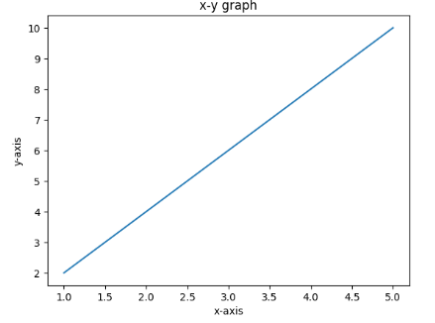
  - Bar graph
import matplotlib.pyplot as plt
subjects=["math","physics","chemistry"]
marks=[90,85,95]
plt.bar(subjects,marks)
plt.xlabel("subjects")
plt.ylabel("marks")
plt.title("Bar chart")
plt.show()
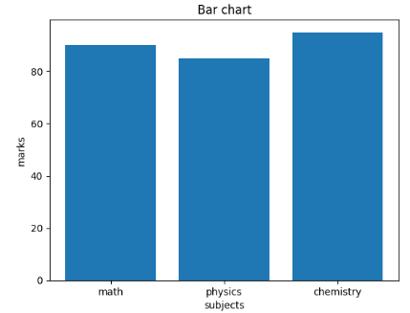

  - Scattered graph
#scatter plot
import matplotlib.pyplot as plt
x = [5, 7, 8, 7, 2, 17]
y = [99, 86, 87, 88, 100, 86]
plt.scatter(x, y, color='blue', marker='o')
plt.title("Scatter Plot Example")
plt.xlabel("X Values")
plt.ylabel("Y Values")
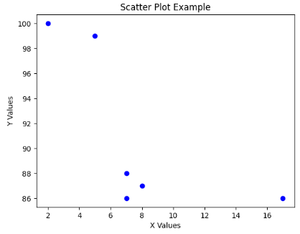

  - Histogram
#histogram
import matplotlib.pyplot as plt
marks = [85, 90, 78, 92, 88, 76, 95, 89, 73, 84,
91, 87, 79, 82, 94, 77, 86, 88, 90, 83]
plt.hist(marks, bins=5, color='green', edgecolor='black')
plt.title("Histogram of Marks")
plt.xlabel("Marks Range")
plt.ylabel("Frequency")
plt.show()
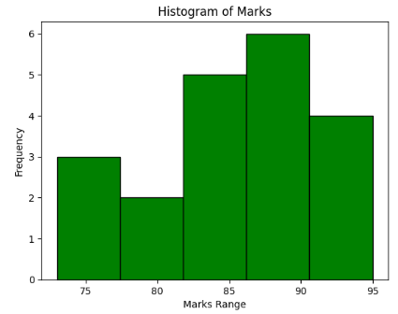

  - Pie chart
#pie chart
import matplotlib.pyplot as plt
subjects = ['Math', 'Science', 'English', 'Computer']
marks = [30, 25, 20, 25]
plt.pie(marks, labels=subjects, autopct='%1.1f%%', startangle=90)
plt.title("Subject Distribution")
plt.axis('equal')
plt.show()

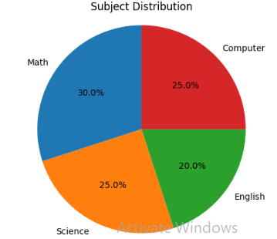

WEEK 3: 17/02/26
- Write the code to implement the following operations on any data set reading from URL
  - Data filtering
  - Data Manipulation
  - Data ranking
#12 dataset operations

import pandas as pd

url = "https://raw.githubusercontent.com/mwaskom/seaborn-data/master/tips.csv"
df = pd.read_csv(url)

print("First few records of dataset")
print(df.head())

print("\nTotal bill > 20 and tip > 3")
cond1 = df[(df['total_bill'] > 20) & (df['tip'] > 3)]
print(cond1)

print("\nRecords on Saturday or Sunday")
cond2 = df[(df['day'] == 'Sat') | (df['day'] == 'Sun')]
print(cond2)

print("\nNon smokers")
cond3 = df[df['smoker'] != 'Yes']
print(cond3)

print("\nFemale, non smoker and bill > 15")
cond4 = df[(df['sex'] == 'Female') & (df['smoker'] == 'No') & (df['total_bill'] > 15)]
print(cond4)

print("Count:", len(cond4))

print("\nSorted by total bill")
s1 = df.sort_values('total_bill')
print(s1.head())

print("\nSorted by tip (descending)")
s2 = df.sort_values('tip', ascending=False)
print(s2.head())

print("\nSorted by day and bill")
s3 = df.sort_values(['day','total_bill'])
print(s3.head())

print("\nAverage total bill per day")
g1 = df.groupby('day')['total_bill'].mean()
print(g1)

print("\nAverage tip by sex and smoker")
g2 = df.groupby(['sex','smoker'])['tip'].mean()
print(g2)

print("\nNumber of records by day")
print(df['day'].value_counts())

Output:

First few records of dataset
total_bill tip sex smoker day time size
0 16.99 1.01 Female No Sun Dinner 2
1 10.34 1.66 Male No Sun Dinner 3
2 21.01 3.50 Male No Sun Dinner 3
3 23.68 3.31 Male No Sun Dinner 2
4 24.59 3.61 Female No Sun Dinner 4

Total bill > 20 and tip > 3
total_bill tip sex smoker day time size
2 21.01 3.50 Male No Sun Dinner 3
3 23.68 3.31 Male No Sun Dinner 2
4 24.59 3.61 Female No Sun Dinner 4
5 25.29 4.71 Male No Sun Dinner 4
7 26.88 3.12 Male No Sun Dinner 4
.. ... ... ... ... ... ... ...
212 48.33 9.00 Male No Sat Dinner 4
214 28.17 6.50 Female Yes Sat Dinner 3
219 30.14 3.09 Female Yes Sat Dinner 4
238 35.83 4.67 Female No Sat Dinner 3
239 29.03 5.92 Male No Sat Dinner 3

[67 rows x 7 columns]

Records on Saturday or Sunday
total_bill tip sex smoker day time size
0 16.99 1.01 Female No Sun Dinner 2
1 10.34 1.66 Male No Sun Dinner 3
2 21.01 3.50 Male No Sun Dinner 3
3 23.68 3.31 Male No Sun Dinner 2
4 24.59 3.61 Female No Sun Dinner 4
.. ... ... ... ... ... ... ...
238 35.83 4.67 Female No Sat Dinner 3
239 29.03 5.92 Male No Sat Dinner 3
240 27.18 2.00 Female Yes Sat Dinner 2
241 22.67 2.00 Male Yes Sat Dinner 2
242 17.82 1.75 Male No Sat Dinner 2

[163 rows x 7 columns]

Non smokers
total_bill tip sex smoker day time size
0 16.99 1.01 Female No Sun Dinner 2
1 10.34 1.66 Male No Sun Dinner 3
2 21.01 3.50 Male No Sun Dinner 3
3 23.68 3.31 Male No Sun Dinner 2
4 24.59 3.61 Female No Sun Dinner 4
.. ... ... ... ... ... ... ...
235 10.07 1.25 Male No Sat Dinner 2
238 35.83 4.67 Female No Sat Dinner 3
239 29.03 5.92 Male No Sat Dinner 3
242 17.82 1.75 Male No Sat Dinner 2
243 18.78 3.00 Female No Thur Dinner 2

[151 rows x 7 columns]

Female, non smoker and bill > 15
total_bill tip sex smoker day time size
0 16.99 1.01 Female No Sun Dinner 2
4 24.59 3.61 Female No Sun Dinner 4
11 35.26 5.00 Female No Sun Dinner 4
18 16.97 3.50 Female No Sun Dinner 3
21 20.29 2.75 Female No Sat Dinner 2
22 15.77 2.23 Female No Sat Dinner 2
29 19.65 3.00 Female No Sat Dinner 2
32 15.06 3.00 Female No Sat Dinner 2
33 20.69 2.45 Female No Sat Dinner 4
37 16.93 3.07 Female No Sat Dinner 3
52 34.81 5.20 Female No Sun Dinner 4
57 26.41 1.50 Female No Sat Dinner 2
66 16.45 2.47 Female No Sat Dinner 2
71 17.07 3.00 Female No Sat Dinner 3
85 34.83 5.17 Female No Thur Lunch 4
94 22.75 3.25 Female No Fri Dinner 2
104 20.92 4.08 Female No Sat Dinner 2
114 25.71 4.00 Female No Sun Dinner 3
115 17.31 3.50 Female No Sun Dinner 2
119 24.08 2.92 Female No Thur Lunch 4
125 29.80 4.20 Female No Thur Lunch 6
131 20.27 2.83 Female No Thur Lunch 2
134 18.26 3.25 Female No Thur Lunch 2
140 17.47 3.50 Female No Thur Lunch 2
143 27.05 5.00 Female No Thur Lunch 6
144 16.43 2.30 Female No Thur Lunch 2
146 18.64 1.36 Female No Thur Lunch 3
155 29.85 5.14 Female No Sun Dinner 5
157 25.00 3.75 Female No Sun Dinner 4
162 16.21 2.00 Female No Sun Dinner 3
223 15.98 3.00 Female No Fri Lunch 3
238 35.83 4.67 Female No Sat Dinner 3
243 18.78 3.00 Female No Thur Dinner 2
Count: 33

Sorted by total bill
total_bill tip sex smoker day time size
67 3.07 1.00 Female Yes Sat Dinner 1
92 5.75 1.00 Female Yes Fri Dinner 2
111 7.25 1.00 Female No Sat Dinner 1
172 7.25 5.15 Male Yes Sun Dinner 2
149 7.51 2.00 Male No Thur Lunch 2

Sorted by tip (descending)
total_bill tip sex smoker day time size
170 50.81 10.00 Male Yes Sat Dinner 3
212 48.33 9.00 Male No Sat Dinner 4
23 39.42 7.58 Male No Sat Dinner 4
59 48.27 6.73 Male No Sat Dinner 4
141 34.30 6.70 Male No Thur Lunch 6

Sorted by day and bill
total_bill tip sex smoker day time size
92 5.75 1.00 Female Yes Fri Dinner 2
222 8.58 1.92 Male Yes Fri Lunch 1
226 10.09 2.00 Female Yes Fri Lunch 2
100 11.35 2.50 Female Yes Fri Dinner 2
97 12.03 1.50 Male Yes Fri Dinner 2

Average total bill per day
day
Fri 17.151579
Sat 20.441379
Sun 21.410000
Thur 17.682742
Name: total_bill, dtype: float64

Average tip by sex and smoker
sex smoker
Female No 2.773519
Yes 2.931515
Male No 3.113402
Yes 3.051167
Name: tip, dtype: float64

Number of records by day
day
Sat 87
Sun 76
Thur 62
Fri 19
Name: count, dtype: int64

- Write the code to implement the following descriptive statistics operations any of the created data frame
  - Mean, Median and mode
  - Standard Deviations
  - Variance
  - Kurtosis
  - Skewness
#13 EDA operations

import pandas as pd
import numpy as np
import matplotlib.pyplot as plt

data = [10,12,15,18,20,22,25,30,35,40]

df = pd.DataFrame(data, columns=["values"])

print("Dataset")
print(df)

print("\nBasic statistics")
print(df.describe())

var = np.var(data)
std = np.std(data)

print("\nVariance:", var)
print("Standard Deviation:", std)

plt.hist(data)
plt.xlabel("Values")
plt.ylabel("Frequency")
plt.title("Histogram of Data")
plt.show()

mean_val = np.mean(data)
median_val = np.median(data)

print("\nMean:", mean_val)
print("Median:", median_val)

print("\nObservation:")
if mean_val > median_val:
print("Data is slightly right skewed")
elif mean_val < median_val:
print("Data is slightly left skewed")
else:
print("Data looks symmetric")

Output:

Dataset
values
0 10
1 12
2 15
3 18
4 20
5 22
6 25
7 30
8 35
9 40

Basic statistics
values
count 10.000000
mean 22.700000
std 9.855061
min 10.000000
25% 15.750000
50% 21.000000
75% 28.750000
max 40.000000

Variance: 87.41
Standard Deviation: 9.34933152690608
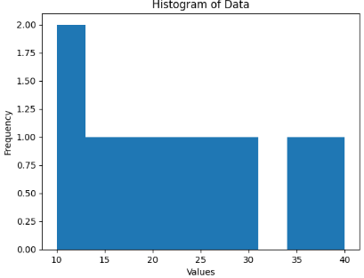
Mean: 22.7
Median: 21.0

Observation:
Data is slightly right skewed

- Read any of the data set from URL and perform the descriptive statistics functions
#14 EDA using dataset URL

import pandas as pd
import numpy as np
import matplotlib.pyplot as plt

url = "https://raw.githubusercontent.com/dataprofessor/data/master/BostonHousing.csv"
df = pd.read_csv(url)

print("First 10 rows of dataset")
print(df.head(10))

data = df['rm']

print("\nSummary statistics")
print(data.describe())

print("\nVariance:", np.var(data))
print("Standard deviation:", np.std(data))

plt.hist(data, bins=10)
plt.xlabel("RM (number of rooms)")
plt.ylabel("Frequency")
plt.title("Distribution of RM values")
plt.show()

mean_val = np.mean(data)
median_val = np.median(data)

print("\nMean:", mean_val)
print("Median:", median_val)

if mean_val > median_val:
print("Data is slightly right skewed")
elif mean_val < median_val:
print("Data is slightly left skewed")
else:
print("Data is symmetric")
Output:

First 10 rows of dataset
crim zn indus chas nox rm age dis rad tax ptratio \
0 0.00632 18.0 2.31 0 0.538 6.575 65.2 4.0900 1 296 15.3
1 0.02731 0.0 7.07 0 0.469 6.421 78.9 4.9671 2 242 17.8
2 0.02729 0.0 7.07 0 0.469 7.185 61.1 4.9671 2 242 17.8
3 0.03237 0.0 2.18 0 0.458 6.998 45.8 6.0622 3 222 18.7
4 0.06905 0.0 2.18 0 0.458 7.147 54.2 6.0622 3 222 18.7
5 0.02985 0.0 2.18 0 0.458 6.430 58.7 6.0622 3 222 18.7
6 0.08829 12.5 7.87 0 0.524 6.012 66.6 5.5605 5 311 15.2
7 0.14455 12.5 7.87 0 0.524 6.172 96.1 5.9505 5 311 15.2
8 0.21124 12.5 7.87 0 0.524 5.631 100.0 6.0821 5 311 15.2
9 0.17004 12.5 7.87 0 0.524 6.004 85.9 6.5921 5 311 15.2

b lstat medv
0 396.90 4.98 24.0
1 396.90 9.14 21.6
2 392.83 4.03 34.7
3 394.63 2.94 33.4
4 396.90 5.33 36.2
5 394.12 5.21 28.7
6 395.60 12.43 22.9
7 396.90 19.15 27.1
8 386.63 29.93 16.5
9 386.71 17.10 18.9

Summary statistics
count 506.000000
mean 6.284634
std 0.702617
min 3.561000
25% 5.885500
50% 6.208500
75% 6.623500
max 8.780000
Name: rm, dtype: float64

Variance: 0.49269521612976347
Standard deviation: 0.7019225143345692
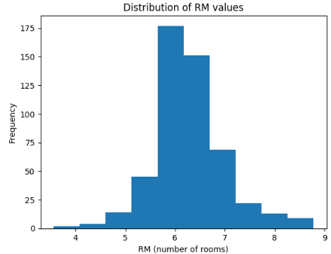
Mean: 6.284634387351779
Median: 6.2085
Data is slightly right skewed

- Read any of the data set from URL and perform the Data visualization methods
#15 Data Visualization

import pandas as pd
import matplotlib.pyplot as plt

url = "https://raw.githubusercontent.com/mwaskom/seaborn-data/master/iris.csv"
df = pd.read_csv(url)

print("First 5 rows")
print(df.head())

print("\nDataset info")
df.info()

plt.plot(df['sepal_length'])
plt.title("Sepal Length")
plt.xlabel("Index")
plt.ylabel("Value")
plt.show()

plt.hist(df['petal_length'], bins=20)
plt.title("Petal Length Histogram")
plt.xlabel("Petal Length")
plt.ylabel("Frequency")
plt.show()

plt.scatter(df['sepal_length'], df['petal_length'])
plt.title("Sepal vs Petal Length")
plt.xlabel("Sepal Length")
plt.ylabel("Petal Length")
plt.show()

df['species'].value_counts().plot(kind='bar')
plt.title("Species Count")
plt.xlabel("Species")
plt.ylabel("Count")
plt.show()

counts = df['species'].value_counts()
plt.pie(counts, labels=counts.index)
plt.title("Species Distribution")
plt.show()
Output:

First 5 rows
sepal_length sepal_width petal_length petal_width species
0 5.1 3.5 1.4 0.2 setosa
1 4.9 3.0 1.4 0.2 setosa
2 4.7 3.2 1.3 0.2 setosa
3 4.6 3.1 1.5 0.2 setosa
4 5.0 3.6 1.4 0.2 setosa

Dataset info
<class 'pandas.core.frame.DataFrame'>
RangeIndex: 150 entries, 0 to 149
Data columns (total 5 columns):
# Column Non-Null Count Dtype
--- ------ -------------- -----
0 sepal_length 150 non-null float64
1 sepal_width 150 non-null float64
2 petal_length 150 non-null float64
3 petal_width 150 non-null float64
4 species 150 non-null object
dtypes: float64(4), object(1)
memory usage: 6.0+ KB
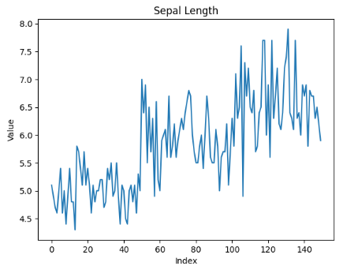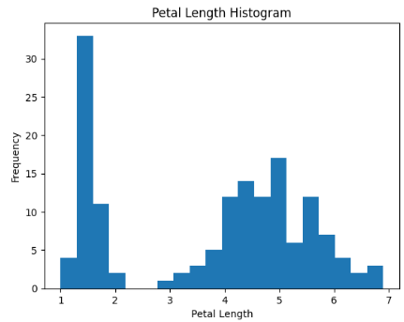

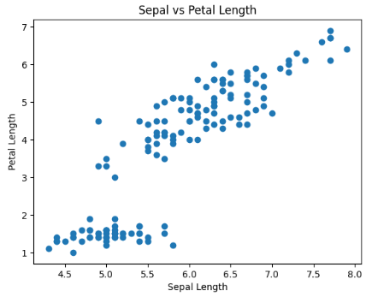

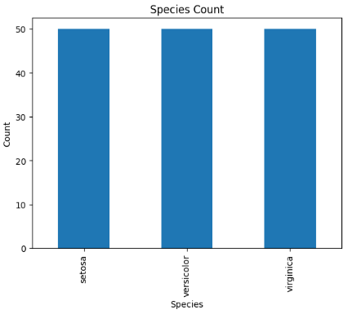

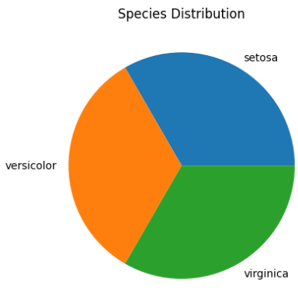

WEEK 4: 24/02/26
- write a python code to perform the following database operations using SQlite
import sqlite3
conn = sqlite3.connect("example.db")
cursor = conn.cursor()
cursor.execute("""
CREATE TABLE IF NOT EXISTS users (
id INTEGER PRIMARY KEY AUTOINCREMENT,
name TEXT NOT NULL,
age INTEGER,
email TEXT UNIQUE
)
""")
print("Table created successfully.")
cursor.execute("INSERT INTO users (name, age, email) VALUES (?, ?, ?)",
("raju", 25, "raju@example.com"))
cursor.execute("INSERT INTO users (name, age, email) VALUES (?, ?, ?)",
("ravi", 30, "ravi@example.com"))
conn.commit()
print("Data inserted successfully.")
cursor.execute("SELECT * FROM users")
rows = cursor.fetchall()
print("\nUsers in database:")
for row in rows:
print(row)
cursor.execute("UPDATE users SET age = ? WHERE name = ?", (28, "raju"))
conn.commit()
print("\nRecord updated successfully.")
cursor.execute("DELETE FROM users WHERE name = ?", ("ravi",))
conn.commit()
print("Record deleted successfully.")
cursor.execute("SELECT * FROM users")
rows = cursor.fetchall()
print("\nFinal data:")
for row in rows:
print(row)
conn.close()
print("\nDatabase connection closed.")

Output:

Table created successfully.
Data inserted successfully.

Users in database:
(1, 'raju', 25, 'raju@example.com')
(2, 'ravi', 30, 'ravi@example.com')

Record updated successfully.
Record deleted successfully.

Final data:
(1, 'raju', 28, 'raju@example.com')

Database connection closed.

- Write the python code to perform the following operations to clean the data
- Missing values
- Sum of missing values
- Replace with mean of the column
import pandas as pd
data = {
'Name': ['Alice', 'Bob', 'Charlie', 'David', 'Eve'],
'Age': [25, None, 35, 40, 28],
'Salary': [50000, 60000, None, 70000, 62000],
'Allowances': [2000, None, 2000, 2000, 2500]
}
df = pd.DataFrame(data)
print("Missing Values Count:\n", df.isnull().sum())
df_cleaned = df.dropna()
print("\nDataFrame after dropping missing values:\n", df_cleaned)
df_filled = df.fillna({'Age': df['Age'].mean(), 'Salary': df['Salary'].mean(), 'Allowances': 2000})
print("\nDataFrame after filling missing values:\n", df_filled)

Output:

Missing Values Count:
Name 0
Age 1
Salary 1
Allowances 1
dtype: int64

DataFrame after dropping missing values:
Name Age Salary Allowances
0 Alice 25.0 50000.0 2000.0
3 David 40.0 70000.0 2000.0
4 Eve 28.0 62000.0 2500.0

DataFrame after filling missing values:
Name Age Salary Allowances
0 Alice 25.0 50000.0 2000.0
1 Bob 32.0 60000.0 2000.0
2 Charlie 35.0 60500.0 2000.0
3 David 40.0 70000.0 2000.0
4 Eve 28.0 62000.0 2500.0

- Implement the data cleaning operations on any data set using URL
import pandas as pd
url = "https://raw.githubusercontent.com/datasciencedojo/datasets/master/titanic.csv"
df = pd.read_csv(url)
print(" Original Dataset Info ")
print(df.info())
print("\n Missing Values Before Cleaning:")
print(df.isnull().sum())
print("\nFirst 5 rows:\n", df.head())
df['Age'] = df['Age'].fillna(df['Age'].median())
df['Embarked'] = df['Embarked'].fillna(df['Embarked'].mode()[0])
print("\nMissing Values After Filling:")
print(df.isnull().sum())
df = df.drop(columns=['Cabin'])
print("\n Columns After Dropping 'Cabin' ")
print(df.columns)
before_duplicates = df.shape[0]
df = df.drop_duplicates()
after_duplicates = df.shape[0]
print(f"\nRemoved {before_duplicates - after_duplicates} duplicate rows")
df['Survived'] = df['Survived'].astype('category')
df['Pclass'] = df['Pclass'].astype('category')
print("\n Data Types After Conversion ")
print(df.dtypes)
df.columns = df.columns.str.lower()
print("\n Columns After Renaming ")
print(df.columns)
Q1 = df['age'].quantile(0.25)
Q3 = df['age'].quantile(0.75)
IQR = Q3 - Q1
lower_bound = Q1 - 1.5 * IQR
upper_bound = Q3 + 1.5 * IQR
before_outliers = df.shape[0]
df = df[(df['age'] >= lower_bound) & (df['age'] <= upper_bound)]
after_outliers = df.shape[0]
print(f"\nRemoved {before_outliers - after_outliers} outlier rows based on Age")
df.to_csv("cleaned_titanic.csv", index=False)
print("\nData Cleaning Completed Successfully!")
print("Cleaned file saved as: cleaned_titanic.csv")
print("\n First 5 rows of Cleaned Dataset ")
print(df.head())
Output:
Original Dataset Info
<class 'pandas.core.frame.DataFrame'>
RangeIndex: 891 entries, 0 to 890
Data columns (total 12 columns):
# Column Non-Null Count Dtype
--- ------ -------------- -----
0 PassengerId 891 non-null int64
1 Survived 891 non-null int64
2 Pclass 891 non-null int64
3 Name 891 non-null object
4 Sex 891 non-null object
5 Age 714 non-null float64
6 SibSp 891 non-null int64
7 Parch 891 non-null int64
8 Ticket 891 non-null object
9 Fare 891 non-null float64
10 Cabin 204 non-null object
11 Embarked 889 non-null object
dtypes: float64(2), int64(5), object(5)
memory usage: 83.7+ KB
None

Missing Values Before Cleaning:
PassengerId 0
Survived 0
Pclass 0
Name 0
Sex 0
Age 177
SibSp 0
Parch 0
Ticket 0
Fare 0
Cabin 687
Embarked 2
dtype: int64

First 5 rows:
PassengerId Survived Pclass \
0 1 0 3
1 2 1 1
2 3 1 3
3 4 1 1
4 5 0 3

Name Sex Age SibSp \
0 Braund, Mr. Owen Harris male 22.0 1
1 Cumings, Mrs. John Bradley (Florence Briggs Th... female 38.0 1
2 Heikkinen, Miss. Laina female 26.0 0
3 Futrelle, Mrs. Jacques Heath (Lily May Peel) female 35.0 1
4 Allen, Mr. William Henry male 35.0 0

Parch Ticket Fare Cabin Embarked
0 0 A/5 21171 7.2500 NaN S
1 0 PC 17599 71.2833 C85 C
2 0 STON/O2. 3101282 7.9250 NaN S
3 0 113803 53.1000 C123 S
4 0 373450 8.0500 NaN S

Missing Values After Filling:
PassengerId 0
Survived 0
Pclass 0
Name 0
Sex 0
Age 0
SibSp 0
Parch 0
Ticket 0
Fare 0
Cabin 687
Embarked 0
dtype: int64

Columns After Dropping 'Cabin'
Index(['PassengerId', 'Survived', 'Pclass', 'Name', 'Sex', 'Age', 'SibSp',
'Parch', 'Ticket', 'Fare', 'Embarked'],
dtype='object')

Removed 0 duplicate rows

Data Types After Conversion
PassengerId int64
Survived category
Pclass category
Name object
Sex object
Age float64
SibSp int64
Parch int64
Ticket object
Fare float64
Embarked object
dtype: object

Columns After Renaming
Index(['passengerid', 'survived', 'pclass', 'name', 'sex', 'age', 'sibsp',
'parch', 'ticket', 'fare', 'embarked'],
dtype='object')

Removed 66 outlier rows based on Age

Data Cleaning Completed Successfully!
Cleaned file saved as: cleaned_titanic.csv

First 5 rows of Cleaned Dataset
passengerid survived pclass \
0 1 0 3
1 2 1 1
2 3 1 3
3 4 1 1
4 5 0 3

name sex age sibsp \
0 Braund, Mr. Owen Harris male 22.0 1
1 Cumings, Mrs. John Bradley (Florence Briggs Th... female 38.0 1
2 Heikkinen, Miss. Laina female 26.0 0
3 Futrelle, Mrs. Jacques Heath (Lily May Peel) female 35.0 1
4 Allen, Mr. William Henry male 35.0 0

parch ticket fare embarked
0 0 A/5 21171 7.2500 S
1 0 PC 17599 71.2833 C
2 0 STON/O2. 3101282 7.9250 S
3 0 113803 53.1000 S
4 0 373450 8.0500 S

- Write the python code to detect the outliers
#IQR meethod
import pandas as pd
data={
"name":['A','B','C','D','E','F'],
"age":[13,24,25,120,23,22]

}

df=pd.DataFrame(data)
q1=df['age'].quantile(0.25)
q3=df['age'].quantile(0.75)
iqr=q3-q1
lower_bound=q1-1.5*iqr
upper_bound=q3+1.5*iqr
outliners=df[(df['age']upper_bound)]
print("outliners using IQR method")
print(outliners)
Output:
outliners using IQR method
name age
0 A 13
3 D 120

- Perform the following operations on data distributions
- Normal distributions
- Left skewness
- Right skewness
# Data Distribution

import numpy as np
import pandas as pd
import matplotlib.pyplot as plt
normal_data = np.random.normal(loc=70, scale=5, size=1000)
right_skewed = np.random.exponential(scale=2, size=1000)
left_skewed = -np.random.exponential(scale=2, size=1000)
plt.hist(normal_data, bins=30)
plt.title("Normal Distribution")
plt.show()
plt.hist(right_skewed, bins=30)
plt.title("Right Skewed Distribution")
plt.show()
plt.hist(left_skewed, bins=30)
plt.title("Left Skewed Distribution")
plt.show()
print("Normal Data Mean:", np.mean(normal_data))
print("Normal Data Median:", np.median(normal_data))

print("Right Skewed Mean:", np.mean(right_skewed))
print("Right Skewed Median:", np.median(right_skewed))

print("Left Skewed Mean:", np.mean(left_skewed))
print("Left Skewed Median:", np.median(left_skewed))
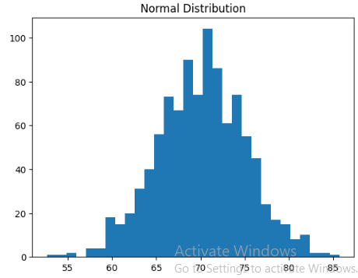

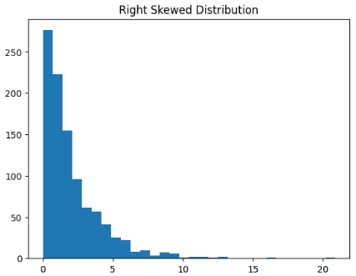
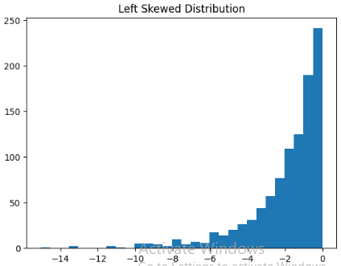

Normal Data Mean: 70.11128462827989
Normal Data Median: 70.29968677048613
Right Skewed Mean: 2.0730665484706994
Right Skewed Median: 1.3947625496295668
Left Skewed Mean: -1.925496961505998
Left Skewed Median: -1.2688244275112757

- Write the code to perform the following operations
- Z-score
- Statistical inference
- random variable model
- Central limit theorem
- Standardizations
#21
import numpy as np
import math
population=np.array([10,20,30,40,50,60,70])
N=len (population)
print("population size(N):",N)
mu=np.mean(population)
print("population mean(u):",mu)
sigma2=np.var(population,ddof=0)
print("population variance(sigma^2):",sigma2)
sigma=np.sqrt(sigma2)
print("population standard deviation:",sigma2)
sample=np.array([20,30,40,50])
n=len(sample)
print("\n sample size(n):",n)
x_bar=np.mean(sample)
print("sample mean:",x_bar)
s2=np.var(sample,ddof=1)
print("sample variance:",s2)
s=np.sqrt(s2)
print("sample standard deviation(s):",s)
SE=sigma/math.sqrt(n)
print("\n standard error:",SE)
z=(x_bar-mu)/SE
print("z-score:",z)
Output:
population size(N): 7
population mean(u): 40.0
population variance(sigma^2): 400.0
population standard deviation: 400.0

sample size(n): 4
sample mean: 35.0
sample variance: 166.66666666666666
sample standard deviation(s): 12.909944487358056

standard error: 10.0
z-score: -0.5

- Write a code to test the hypothesis, if test for Z is accepted or rejected
import math
n=100
x=60
p_hat=x/n
SE=math.sqrt(p_hat*(1-p_hat)/n)
z=1.96
lower=p_hat-z*SE
upper=p_hat+z*SE
print("Sample proportion=",p_hat)
print("Confidence Interval=",(lower,upper))
p0=0.50
z_test=(p_hat-p0)/math.sqrt(p0*(1-p0)/n)
print("z value=",z_test)
if abs(z_test)>1.96:
print("Reject Ho")
else:
print("Do not reject Ho")
Output:
Sample proportion= 0.6
Confidence Interval= (0.5039800020828994, 0.6960199979171006)
z value= 1.9999999999999996
Reject Ho

WEEK 6: 24/03/26
- Write a code to implement linear regression on any sample dataset
#23 linear regression on any sample dataset
import numpy as np
import matplotlib.pyplot as plt
from sklearn.linear_model import LinearRegression
X=np.array([1,2,3,4,5]).reshape(-1,1)
Y=np.array([30,35,50,55,65])
model=LinearRegression()
model.fit(X,Y)
predictions=model.predict(X)
print("Slope:",model.coef_)
print("Intercept:",model.intercept_)
plt.scatter(X,Y)
plt.plot(X,predictions)
plt.xlabel("experience")
plt.ylabel("salary")
plt.title("Linear Regression")
plt.show()

Output:

Slope: [9.]
Intercept: 19.999999999999993
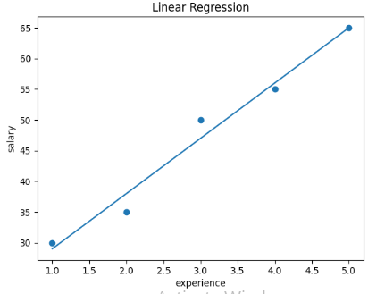
- Write a code to implement linear regression with example url
#24 linear regression with an example URL
import matplotlib.pyplot as plt
import pandas as pd
from sklearn.linear_model import LinearRegression
from sklearn.metrics import mean_squared_error
url=("https://raw.githubusercontent.com/ybi-foundation/dataset/main/Salary%20Data.csv")
data=pd.read_csv(url)
print("Data preview")
print(data.head())
X=data[['Experience Years']]
Y=data['Salary']
model.fit(X,Y)
print("model prediction")
print("slope:",model.coef_[0])
print("intercept:",model.intercept_)
years=[[5]]
predicted_salary=model.predict(years)
print ("\n predict salary for 5 years experience:",predicted_salary[0])
Y_pred=model.predict(X)
mse=mean_squared_error(Y,Y_pred)
print("\n Mean Squared Error:",mse)
plt.scatter(X,Y)
plt.plot(X,Y_pred)
plt.xlabel("Experience years")
plt.ylabel("Salary")
plt.title("Linear Regression")
plt.show()

Output:
Data preview
Experience Years Salary
0 1.1 39343
1 1.2 42774
2 1.3 46205
3 1.5 37731
4 2.0 43525
model prediction
slope: 9523.650507417704
intercept: 25673.01576053028

predict salary for 5 years experience: 73291.26829761881

Mean Squared Error: 28960383.65377621

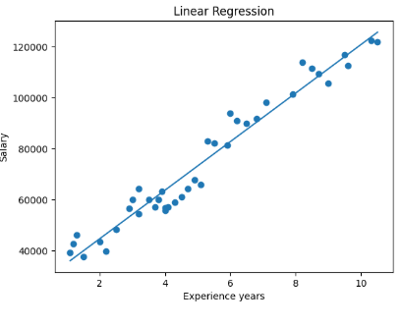
- Write a code to implement logistic regression to find the following—
- spam or not spam
#25.a logistic regression spam or no spam
import pandas as pd
from sklearn.linear_model import LogisticRegression
from sklearn.model_selection import train_test_split
from sklearn.metrics import accuracy_score,confusion_matrix
data = {
"links": [0, 2, 1, 3, 0, 4],
"spam": [0, 1, 0, 1, 0, 1]
}
df = pd.DataFrame(data)
X = df[["links"]]
y = df["spam"]
X_train, X_test, y_train, y_test = train_test_split(X, y, test_size=0.2, random_state=42)
model = LogisticRegression()
model.fit(X_train, y_train)
y_pred = model.predict(X_test)
accuracy = accuracy_score(y_test, y_pred)
print("Accuracy:", accuracy)
Output:
Accuracy: 0.5

- disease or no disease
#25.b logistic regression disease or no disease
import pandas as pd
from sklearn.linear_model import LogisticRegression
from sklearn.model_selection import train_test_split
from sklearn.metrics import accuracy_score,confusion_matrix
data = {
"BP": [120, 140, 130, 150, 110, 160],
"disease": [0, 1, 0, 1, 0, 1]
}
df = pd.DataFrame(data)
X = df[["BP"]]
y = df["disease"]
X_train, X_test, y_train, y_test = train_test_split(X, y, test_size=0.2, random_state=42)
model = LogisticRegression()
model.fit(X_train, y_train)
y_pred = model.predict(X_test)
accuracy = accuracy_score(y_test, y_pred)
print("Accuracy:", accuracy)
Output:
Accuracy: 1.0

- sentiment analysis positive or negative
#25.c logistic regression sentimental analysis positive or negative
import pandas as pd
from sklearn.linear_model import LogisticRegression
from sklearn.model_selection import train_test_split
from sklearn.metrics import accuracy_score,confusion_matrix
data = {
"length": [5, 20, 15, 30, 10, 25],
"sentiment": [0, 1, 0, 1, 0, 1]
}
df = pd.DataFrame(data)
X = df[["length"]]
y = df["sentiment"]
X_train, X_test, y_train, y_test = train_test_split(X, y, test_size=0.2, random_state=42)
model = LogisticRegression()
model.fit(X_train, y_train)
y_pred = model.predict(X_test)
accuracy = accuracy_score(y_test, y_pred)
print("Accuracy:", accuracy)
Output:
Accuracy: 1.0

WEEK 7: 31/03/26
- Write a code to implement logistic regression work with url to find the given patients are having diabetes or not
#26logistic regression with URL
import pandas as pd
from sklearn.model_selection import train_test_split
from sklearn.linear_model import LogisticRegression
from sklearn.metrics import accuracy_score,confusion_matrix
url="https://raw.githubusercontent.com/jbrownlee/Datasets/master/pima-indians-diabetes.data.csv"
columns=[
"Pregnancies",
"Glucose",
"BloodPressure",
"SkinThickness",
"Insulin","BMI","DiabetesPedigreeFunction","Age","Outcome"
]
data=pd.read_csv(url,names=columns)
print("Dataset Preview")
print(data.head())
X=data.drop("Outcome",axis=1)
y=data["Outcome"]
X_train,X_test,y_train,y_test=train_test_split(X,y,test_size=0.2,random_state=42)
model=LogisticRegression(max_iter=1000)
model.fit(X_train,y_train)
y_pred=model.predict(X_test)
accuracy=accuracy_score(y_test,y_pred)
print("Accuracy:",accuracy)
print("Confusion Matrix:")
print(confusion_matrix(y_test,y_pred))
sample=[[2,120,70,20,85,30,0.5,25]]
prediction=model.predict(sample)
print("\n Diabetes Prediction (0=No,1=Yes):",prediction)
Output:
Dataset Preview
Pregnancies Glucose BloodPressure SkinThickness Insulin BMI \
0 6 148 72 35 0 33.6
1 1 85 66 29 0 26.6
2 8 183 64 0 0 23.3
3 1 89 66 23 94 28.1
4 0 137 40 35 168 43.1

DiabetesPedigreeFunction Age Outcome
0 0.627 50 1
1 0.351 31 0
2 0.672 32 1
3 0.167 21 0
4 2.288 33 1
Accuracy: 0.7467532467532467
Confusion Matrix:
[[78 21]
[18 37]]

Diabetes Prediction (0=No,1=Yes): [0]

WEEK 8: 21/04/26
#27 confusuion matrix
from sklearn.metrics import confusion_matrix,precision_score,recall_score,f1_score,roc_curve,auc
import matplotlib.pyplot as plt
y_true=[1,0,1,0,1,0,1,0]
y_pred=[1,1,1,0,0,0,1,0]
cm=confusion_matrix(y_true,y_pred)
print("confusion matrix:",cm)
print("precision:",precision_score(y_true,y_pred))
print("Recall:", recall_score(y_true,y_pred))
print("F1:",f1_score(y_true,y_pred))
y_score=[0.9,0.6,0.8,0.3,0.4,0.2,0.85,0.1]
fpr,tpr,_=roc_curve(y_true,y_score)
roc_auc=auc(fpr,tpr)
print("AUC:",roc_auc)
plt.plot(fpr,tpr)
plt.xlabel("FPR")
plt.ylabel("TPR")
plt.title("ploc curve")
plt.show()

OUTPUT:

confusion matrix: [[3 1]
[1 3]]
precision: 0.75
Recall: 0.75
F1: 0.75
AUC: 0.9375
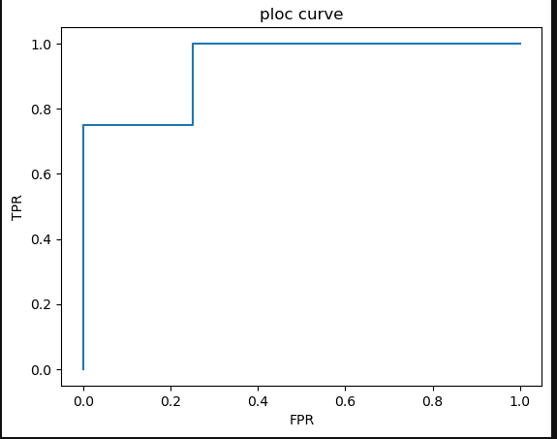

#28 svm
from sklearn import svm
x=[[2,2],[4,4],[2,0],[0,2]]
y=[1,1,-1,-1]
model=svm.SVC(kernel='linear')
model.fit(x,y)
print(model.predict([[0,0]]))

OUTPUT:

[-1]

#29 polynomial regression
import numpy as np
import matplotlib.pyplot as plt
from sklearn.preprocessing import PolynomialFeatures
from sklearn.linear_model import LinearRegression
x=np.array([1,2,3,4]).reshape(-1,1)
y=np.array([1,4,9,16])
poly=PolynomialFeatures(degree=2)
x_poly=poly.fit_transform(x)
model=LinearRegression()
model.fit(x_poly,y)
y_pred=model.predict(x_poly)
plt.scatter(x,y)
plt.plot(x,y_pred)
plt.show()

OUTPUT:
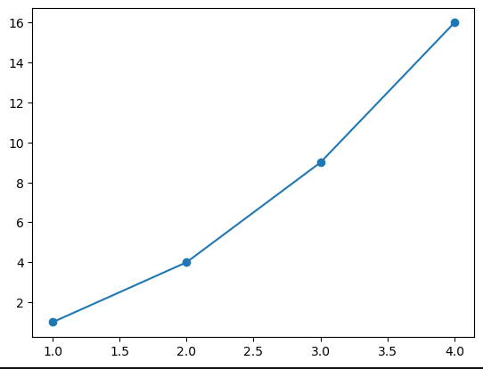

#30 decision tree
from sklearn.tree import DecisionTreeClassifier
x=[[1,1],[1,0],[0,1],[0,0]]
y=[0,1,1,0]
model=DecisionTreeClassifier()
model.fit(x,y)
print(model.predict([[0,1]]))

OUTPUT:
[1]

#30 decision tree
from sklearn.tree import DecisionTreeClassifier
x=[[1,1,1],[1,0,1],[0,1,0],[0,0,0]]
y=[1,1,0,0]
model=DecisionTreeClassifier()
model.fit(x,y)
print(model.predict([[1,0,1]]))

OUTPUT:
[1]

WEEK 9: 28/04/26
#32 lasso code
from sklearn.linear_model import Lasso
import numpy as np
x=np.array([[1,25,160],[2,30,165],[3,35,170]])
y=np.array([30000,40000,50000])
model=Lasso(alpha=0.1)
model.fit(x,y)
print(model.coef_)

OUTPUT:
[9.99973000e+03 4.80000000e-02 3.33066907e-18]

#32 lasso supervised
import numpy as np
from sklearn.linear_model import Lasso
x=np.array([[1,5,2],[2,6,4],[3,7,6],[4,0,8]])
y=np.array([5,10,15,20])
model=Lasso(alpha=0.1)
model.fit(x,y)
print("coefficients:",model.coef_)

OUTPUT:
coefficients: [ 0. -0. 2.48]

#33 similarity and distances
import numpy as np
from scipy.spatial import distance
from scipy.stats import pearsonr
point1=np.array([2,3])
point2=np.array([5,7])
euclidean=distance.euclidean(point1,point1)
manhattan=distance.cityblock(point1,point2)
chebyshev=distance.chebyshev(point1,point2)
hamming=distance.hamming(point1,point2)
cosine_distance=distance.cosine(point1,point2)
cosine_similarity=1-cosine_distance
set1,set2=set(point1),set(point2)
jaccard_similarity=len(set1&set2)/len(set1|set2)
r=pearsonr(point1,point2)
print("euclidean distance:",euclidean)
print("Manhattam distance:",manhattan)
print("chebyshev distance:",chebyshev)
print("cosine distance:",cosine_distance)
print("Jaccard similarity:",jaccard_similarity)
print("pearsonr correlation:",r)
print("cosine similarity:",cosine_similarity)

OUTPUT:

euclidean distance: 0.0
Manhattam distance: 7
chebyshev distance: 4
cosine distance: 0.0005198856603004787
Jaccard similarity: 0.0
pearsonr correlation: PearsonRResult(statistic=1.0, pvalue=1.0)
cosine similarity: 0.9994801143396995

#34 K-means clustering
import numpy as np
A=np.array([[2,3],[3,4],[4,2]])
B=np.array([[8,7],[9,6],[10,8]])
P=np.array([5,5])
CA=A.mean(axis=0)
CB=B.mean(axis=0)
dA=np.linalg.norm(P-CA)
dB=np.linalg.norm(P-CB)
if dA<dB:
print("point belongs to cluster A")
else:
print("point belongs to cluster B")

OUTPUT:

point belongs to cluster A

